2014 Summer Long Track Camp
August 20 – 24, 2014
Pomeroy Sport Centre
Fort St John, BC

FEATURING COACHES:

Tonny Knoll

Tonny has a long and impressive background as a professional athlete in speed skating. With wins in 10 Dutch Championships, 2 European Championships, 7 World Cups, Dutch Sports Woman of the Year, and 3-time Olympian, she knows how to train hard and focus on a goal. Through her background in speed skating, Tonny has both breadth and depth of knowledge in a number of areas, including running, cycling, weight lifting, and circuit training. In addition to years of elite level competition, Tonny has completed her Alberta Fitness Leader Certification Association exercise theory. It gives Tonny great satisfaction to share her knowledge with others who strive to live a healthy and active life.

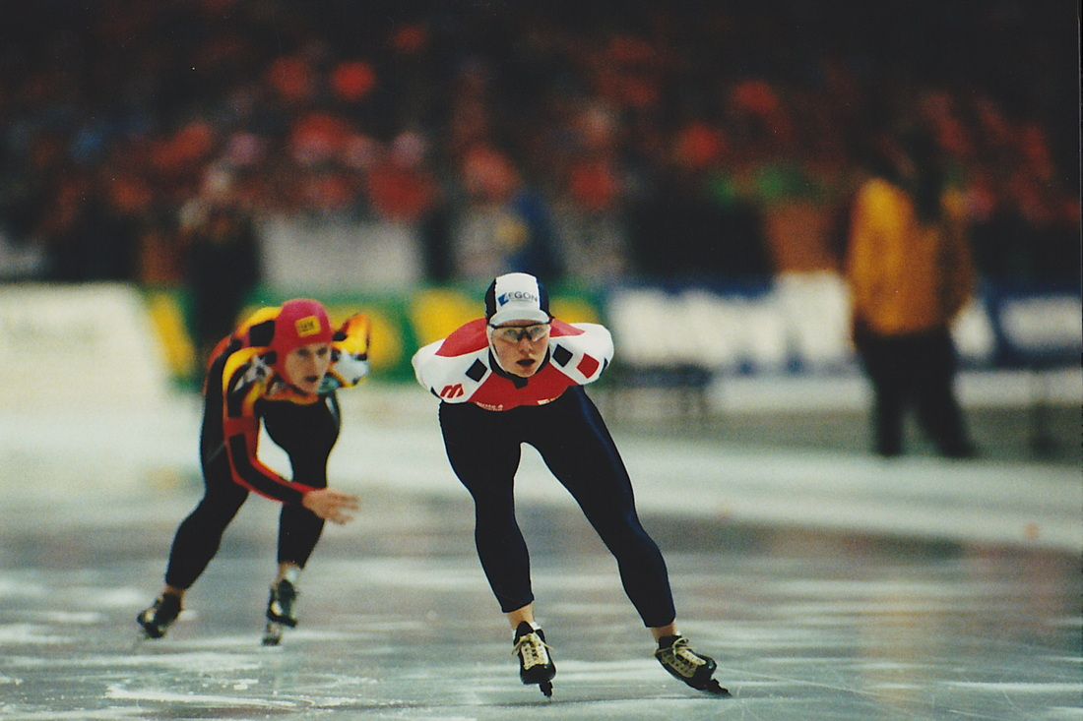
Mark Knoll

Mark developed a reputation as a determined competitor, mastering the ability to squeeze out every bit of performance from his potential. Mark finished second overall to Bob deJong twice in the Junior World Championships. Mark competed in 6 World Championships and two Olympic Games. He was a Canadian Speed Skating Team Member from 1993 – 2003.

Mark Knoll has discovered that there's an important gap between the junior and senior level in long track speed skating. Mark was one of Canada's best ever junior performers. He was the first Canadian in 13 years to earn an overall medal at the world junior championships placing second in 1995 and 1996. He also ended a six-year Canadian medal drought at the world juniors with silver medals in the 3,000 and 5,000 metres. Mark was also involved in the Special Olympic speed skating program.
After a rewarding junior career, Mark worked hard to prove himself as a world contender, but never achieved the same level of success on the World Cup circuit or World Championships. After competing in his second Olympics, Mark accepted an offer to compete with a Division III Professional Cycling Team based out of the Netherlands, and enjoyed a challenging spring classic campaign before returning home to attend the University of Calgary. Mark currently lives in Calgary with his wife Tonny, a former professional speed skater, and their three children. Mark is currently an English teacher at Westmount Charter School in Calgary.
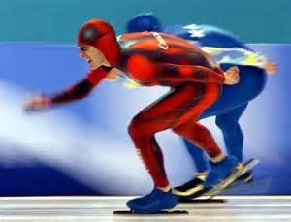

Jack Walters
Jack Walters started skating at three years of age due to the interest of his parents, who had met while skating. He won the National Long Track and tied for the National Short Track as a Senior in 1971. His championship career started by winning the 1957 Midget National Short Track Championship and the 1961 Junior Short Track National Championship. Jack was the alternate member of the 1972 U. S. Olympic Speed Skating team. He came to Canada and developed the coaching certification system in Canada and served as National Coach of Canada from 1978 to 1994 developing many of Canada’s best ever speed skaters from Gaetan Boucher to Catriona Lemay and Susan Auch. Jack is now recognized internationally as one of the premier resources for Speed Skating knowledge with an amazing ability to breakdown the technical components of the sport to an understandable and executable level.
